WEEK 4: PREDICTIVE MODELING AND OPTIMIZATION IN LOGISTICS
Forecasting Delivery Time and Optimizing Regional Capacity
Prepared by: Kanishka Sapra
Dataset: Hypothetical / Synthetic Logistics Dataset
Tools: Python, Pandas, Scikit-learn, SciPy and Matplotlib

1. Problem Definition
The logistics problem addressed in this project is the prediction of delivery time for an individual shipment. Accurate delivery-time estimates can support customer communication, carrier planning, staffing and capacity allocation. The predictive target is delivery_days, a continuous numerical variable representing the simulated number of days from shipment to delivery.
The second part of the project is prescriptive: use predicted operational risk as an input to an illustrative capacity-allocation optimization. The optimization does not claim to produce a real company's schedule; it demonstrates how predictive analytics can be connected to an operations-research model.

2. Dataset and Features
Feature | Type | Description | Role
region | Categorical | North, South, East, West | Geographic context
transport_mode | Categorical | Road, Rail, Air | Transportation choice
priority | Categorical | Standard or Express | Service priority
shipment_volume | Numeric | Units in shipment | Workload/capacity
distance_km | Numeric | Shipment distance | Route complexity
weather | Categorical | Normal or Adverse | Operational disruption
congestion_index | Numeric | 0 to 1 simulated index | Traffic condition
delivery_days | Numeric | Actual delivery duration | Prediction target

3. Data Simulation
A synthetic dataset of 500 shipment records was generated. The data were designed to contain plausible relationships: longer distances tend to increase delivery time, adverse weather adds delay, congestion increases delivery duration, and express priority reduces expected delivery time. Random variation was added so that the modelling task is not perfectly deterministic.
Because the dataset is synthetic, the numerical results in this report are demonstrations of the modelling workflow and are not claims about real logistics operations.

4. Analysis Flow
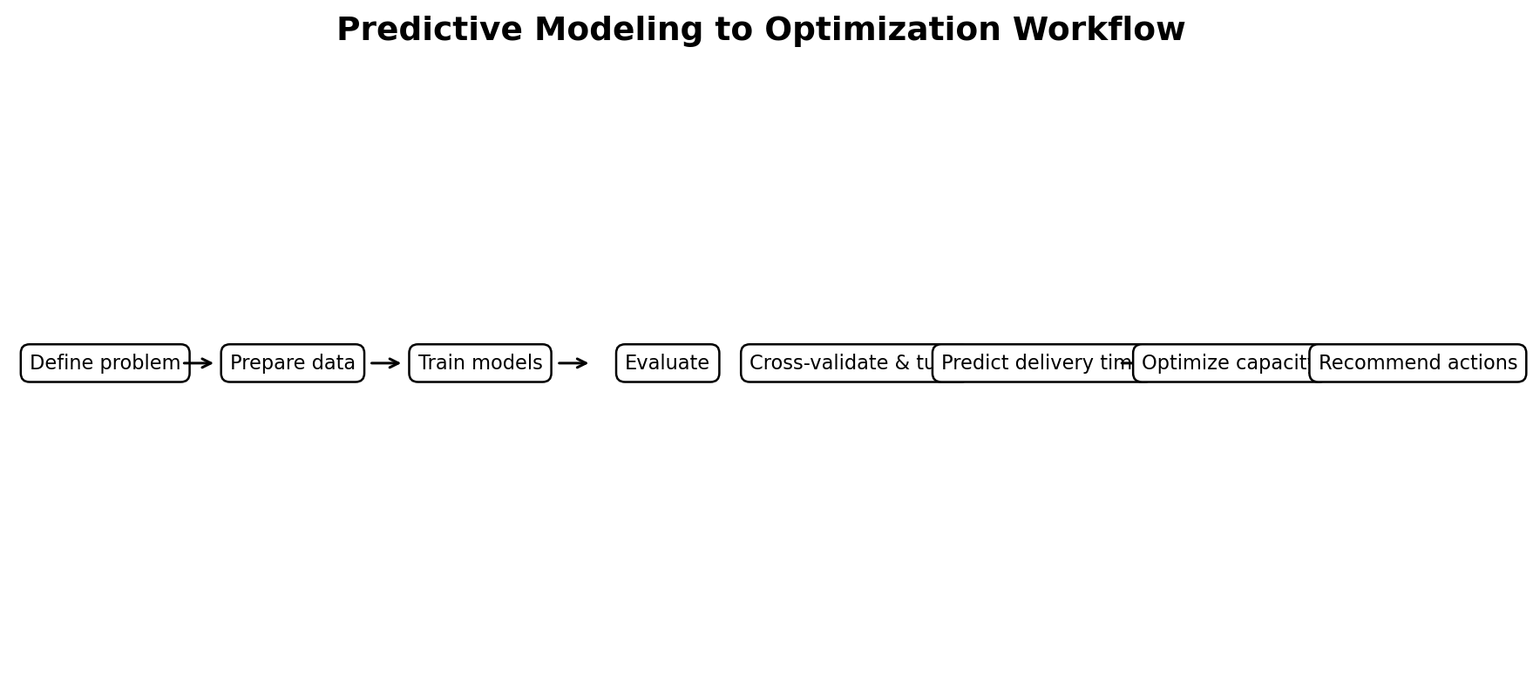
Figure 1. End-to-end predictive and optimization workflow.

5. Model Selection
Three regression approaches are compared. Linear Regression provides a simple and interpretable baseline. A Decision Tree Regressor can capture non-linear relationships and interactions. Random Forest combines many decision trees and is proposed as the main model because logistics relationships can be non-linear; for example, the effect of distance can vary by transport mode and congestion.
Model | MAE | RMSE | R²
Linear Regression | 0.546 | 0.687 | 0.646
Decision Tree | 0.669 | 0.849 | 0.458
Random Forest | 0.578 | 0.725 | 0.606

6. Model Evaluation
MAE measures the average absolute prediction error in days and is easy to interpret operationally. RMSE gives greater weight to larger errors, which is useful when very inaccurate delivery forecasts are especially costly. R-squared describes the proportion of variation explained by the model relative to a mean-only baseline.
The tuned Random Forest achieved a test MAE of 0.575 days, RMSE of 0.712 days and R² of 0.619 on the held-out test set. Five-fold cross-validation of the initial Random Forest produced an average RMSE of 0.787 days. These values are specific to the synthetic dataset and should not be interpreted as real-world performance.
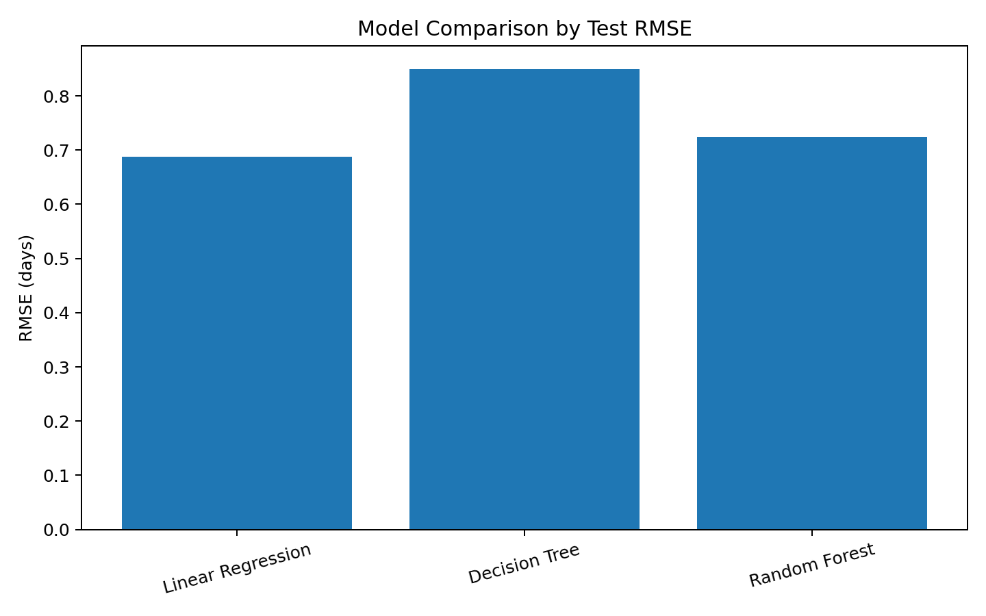
Figure 2. Test-set RMSE comparison.
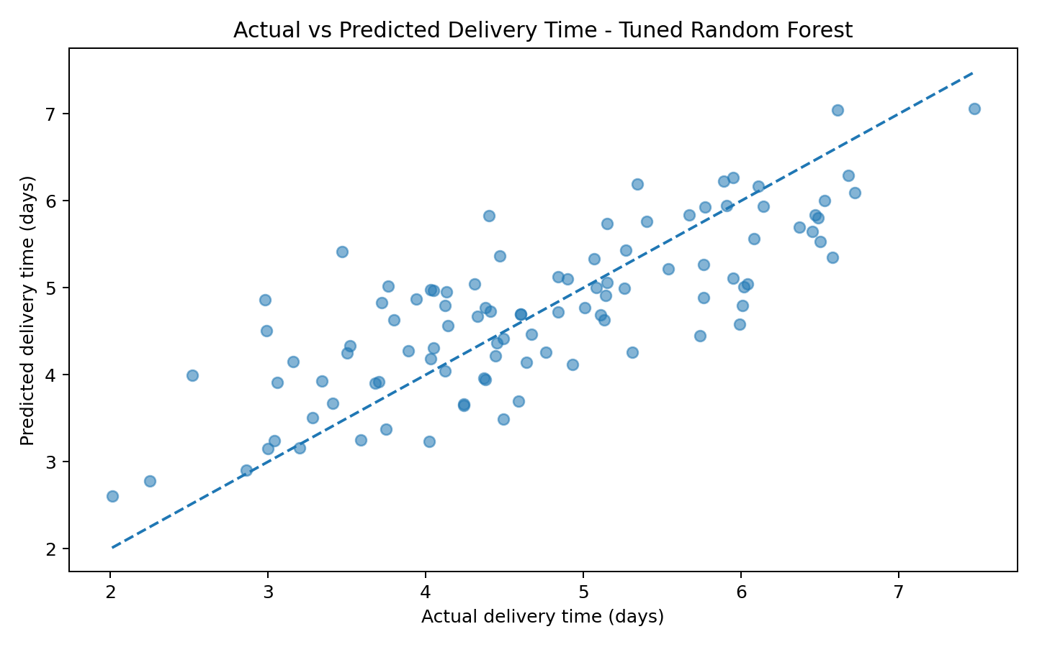
Figure 3. Actual versus predicted delivery time for the tuned Random Forest.

7. Cross-Validation and Hyperparameter Tuning
A five-fold K-Fold cross-validation strategy is used to reduce dependence on one train/test split. The training data are divided into five folds; the model trains on four folds and validates on the remaining fold, repeated five times. The average validation RMSE provides a more stable estimate of generalization.
GridSearchCV tests Random Forest maximum depth values of 6, 10 and 14 and minimum leaf sizes of 1, 3 and 5. The selected parameter combination was: {'model__max_depth': 14, 'model__min_samples_leaf': 3}. Hyperparameter tuning is performed only on the training data so that the final test set remains an unbiased evaluation set.

8. Optimization Strategy
Prediction answers 'what is likely to happen?' Optimization addresses 'what should we do under constraints?' The proposed optimization example allocates a total of 1,000 regional capacity units across North, South, East and West. Each region has a minimum capacity of 120 and maximum of 350. The objective is to minimize a risk-adjusted cost coefficient. In a real system, the coefficient could incorporate carrier cost, predicted delay risk, demand, service-level penalties and capacity availability.
Region | Risk-adjusted cost | Illustrative allocation
North | 12.13 | 180
South | 10.82 | 350
East | 12.94 | 120
West | 11.27 | 350
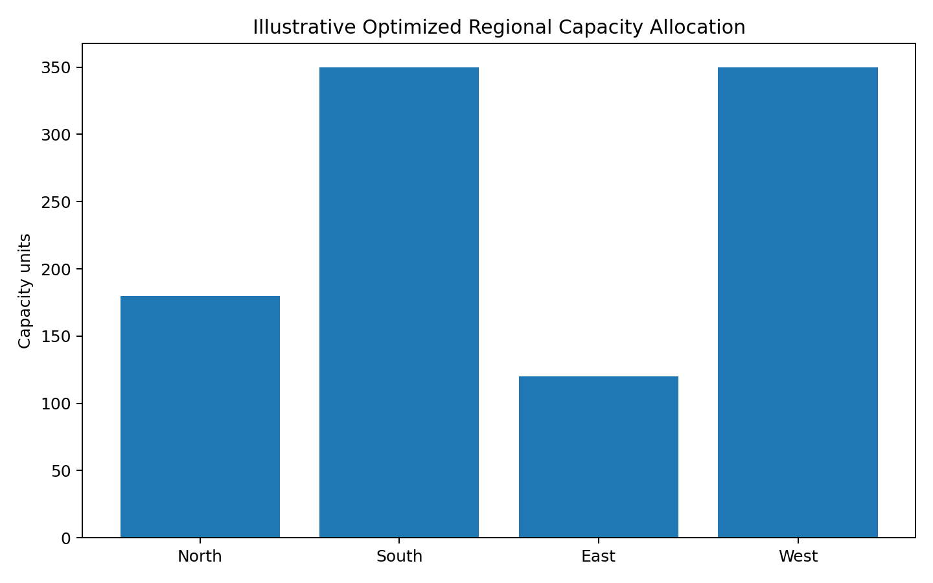
Figure 4. Illustrative optimized capacity allocation.

9. Optimization Formulation
Let xᵢ be capacity allocated to region i and cᵢ be the risk-adjusted cost coefficient. The simplified objective is:
Minimize Σ cᵢxᵢ
Subject to: Σxᵢ = 1,000; 120 ≤ xᵢ ≤ 350 for each region.
This is a simplified linear-programming example. A production logistics optimization would normally add constraints for vehicle capacity, route time, driver availability, warehouse stock, delivery windows, carrier contracts and demand.

10. Python Code Illustration
# Train/test split
X_train, X_test, y_train, y_test = train_test_split(
X, y, test_size=0.20, random_state=42
)
# Random Forest regression
model = Pipeline([
("preprocess", preprocess),
("model", RandomForestRegressor(
n_estimators=250,
max_depth=10,
random_state=42
))
])
model.fit(X_train, y_train)
pred = model.predict(X_test)
# Evaluation
mae = mean_absolute_error(y_test, pred)
rmse = mean_squared_error(y_test, pred) ** 0.5
r2 = r2_score(y_test, pred)
print(mae, rmse, r2)
# Hyperparameter tuning
grid = GridSearchCV(
model,
{
"model__max_depth": [6, 10, 14],
"model__min_samples_leaf": [1, 3, 5]
},
cv=5,
scoring="neg_root_mean_squared_error"
)
grid.fit(X_train, y_train)
# Linear programming example
result = linprog(
cost,
A_eq=[np.ones(4)],
b_eq=[1000],
bounds=[(120, 350)] * 4,
method="highs"
)

11. Actionable Logistics Recommendations
- Use predicted delivery time as an early-warning signal so operations teams can investigate shipments with unusually high predicted duration.
- Use transport-mode performance together with cost and capacity rather than optimizing delivery time alone.
- Allocate additional capacity to regions where demand and predicted delay risk are simultaneously high.
- Use weather and congestion information as dynamic features when a real-time system is available.
- Re-train and monitor the predictive model periodically because logistics patterns can change over time.
- Evaluate optimization decisions against service-level requirements before implementation.
- Keep human operational review in the decision loop, especially for exceptional shipments.

12. Limitations
The dataset and cost coefficients are hypothetical. Therefore, model metrics and the optimized allocations are demonstrations, not real business forecasts. The simulation also omits live traffic, actual carrier prices, vehicle capacities, inventory constraints and detailed route networks. A real deployment would require time-based validation, monitoring for data drift, additional operational constraints and testing on current historical data.

13. Conclusion
This project demonstrates the complete transition from predictive analytics to prescriptive decision support in a logistics setting. Delivery time is modelled as a continuous target using Linear Regression, Decision Tree and Random Forest methods. MAE, RMSE and R² are used for evaluation, while cross-validation and grid search support model selection. The predictive output is then connected to an illustrative linear optimization problem for regional capacity allocation. This workflow shows how logistics teams can move from forecasting operational conditions to evaluating constrained resource-allocation decisions.

14. References / Technical Documentation
scikit-learn User Guide — supervised learning, model selection, preprocessing and evaluation: https://scikit-learn.org/stable/user_guide.html
SciPy Optimize documentation — linear programming and optimization: https://docs.scipy.org/doc/scipy/reference/optimize.html
pandas documentation — data manipulation and analysis: https://pandas.pydata.org/docs/
Matplotlib documentation — visualization: https://matplotlib.org/stable/

15. Project Files
The GitHub-ready project contains the synthetic dataset, Python modelling and optimization script, requirements file, README, visual outputs and this report. The dataset is intentionally synthetic to match the assignment's hypothetical-data requirement.

